AI's Role in Resume Screening & Candidate Selection
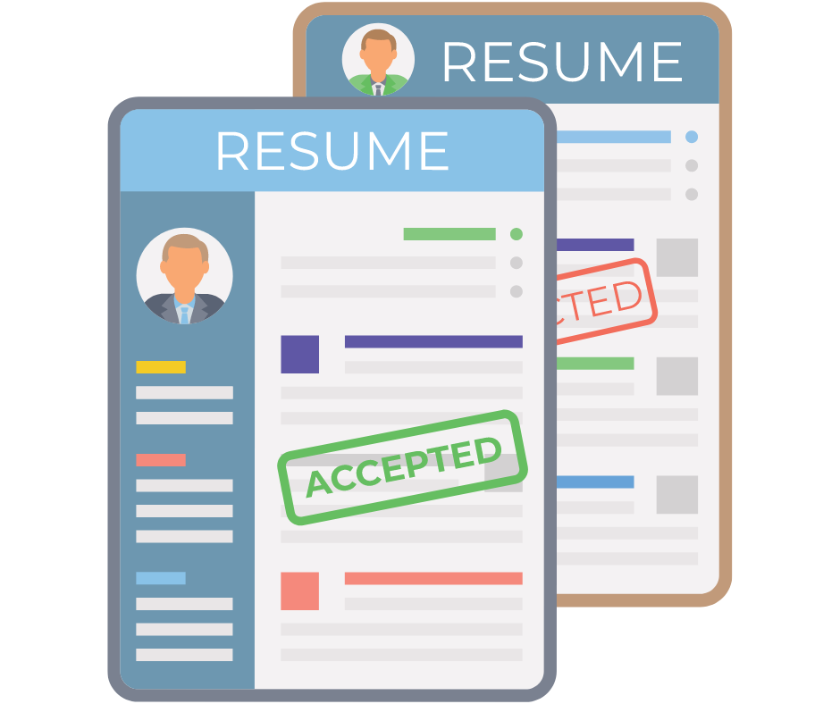

AI is bringing on a revolution into resume screening & candidate selection. By leveraging machine learning algorithms, AI can swiftly analyze resumes, identifying relevant skills & experience. This automation speeds up the process, reduces bias thus ensuring fairer evaluations.
Additionally, AI tools can predict candidate success based on historical data, improving hiring outcomes. Overall, AI enhances efficiency & accuracy in the recruitment process, transforming how companies find & select top talent.
Due to all these benefits, AI is now widely used by hiring companies for resume screening & candidate selection through job hiring websites. This blog will take you through the ways AI is used for resume screening which will further enable you to draft your AI-friendly resume.

How is AI used in Resume Screening?
Automated Resume Parsing
A resume parser extracts information from a candidate’s resume, analyses it & organizes it the way the hiring managers want it to be reviewed. AI algorithms can efficiently extract relevant information from resumes, such as work experience, skills, education & certifications. This helps streamline the initial screening process by quickly filtering out candidates who do not meet basic qualifications & saves time & effort.

Enhanced Candidate Matching
Coming up with a shortlist of candidates is a time-consuming task. By automating routine tasks like resume screening, AI frees up recruiters to focus more on engaging with candidates, providing a better overall candidate experience.

Bias Reduction
AI can help reduce unconscious bias in the initial screening phase by focusing solely on qualifications & experience rather than demographic factors like gender, race, or age. This promotes fairer hiring practices ensuring that each candidate who is offered a role is entirely due to his/ her merit.

Keyword Matching
AI can match keywords from job descriptions to resumes, helping recruiters identify candidates whose skills & experience closely align with the job requirements. This improves the efficiency of identifying potentially suitable candidates.

Predictive Analysis
Some AI tools use historical hiring data to predict which candidates are likely to succeed based on past hiring patterns & employee performance metrics. This can aid recruiters in making more informed decisions.

Natural Language Processing (NLP)
Natural Language Processing focuses on the interaction between computer & human language. With the help of this AI tool, computers can understand human language, analyze it & interpret it easily.

Personalized Candidate Engagement
A negative onboarding experience might change the minds of your candidates. By automating routine tasks like resume screening, AI frees up recruiters to focus more on engaging with candidates, providing a better overall candidate experience.

Continuous Learning & Improvement
AI is designed in such a way that it shortens the hiring process. It can screen hundreds of resumes within minutes which would have taken days otherwise. This saves a lot of time of hiring managers, allowing them to improve the hiring process further.

Scalability & Cost efficiency
AI-powered systems can handle a large volume of resumes much faster than human recruiters, making it easier for organizations to manage high applicant volumes & ensure that no qualified candidates are overlooked.

Conclusion
Going through the difficult process of resume screening is not easy. You need to craft your resume in such a way that it can pass the Applicant Tracking Systems (ATS). There are many websites that offer you free resume score check, one being PaintMinds. With the help of PaintMinds AI powered score checker, evaluate your resume & its performance. Build your resume with PaintMinds’ resume maker & pass the resume screening test!

